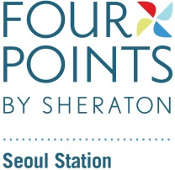 Accommodation Registration Form
DX KOREA 2022
Please completed and send to sales Manager emails jade.kim@fourpointsjosun.com
RESERVATION DETAILS
Check-in Date |  | Arrival Flight |  | ETA
Check-out Date |  | Departure Flight |  | ETD
Last Name |  | First Name
Phone |  | Country
E-mail

ROOM TYPE
Room Type |  | RACK RATE | Special Rate | Breakfast
Superior | □Double □Twin | KRW 350,000++ | KRW 100,000++ | 18,000++
Deluxe | □King □Twin | KRW 400,000++ | KRW 140,000++ | 18,000++
·The above rates are subject to 10% Service Charge and 11% VAT
·All rates quoted are net and on a per room per night basis.

TREMS AND CONDITIONS
·Check-in time is after 15:00hrs. Check-out time is before 12:00hrs. For any guests who would like immediate guaranteed access to their rooms prior to 14:00hrs check-in time, this will be subject to acailability
·Any no-shows or cancellations received not within 24 hours notice, the cost of one nights room charge will be charged to credit card
·By providing above mentioned credit card details, cardholder agrees to the reservation guarantee policy.

Authorized Approval(Block Letters)
Signature Date
Guarateed by | - AMEX □Diners □JCB □Mastercard □Visa
Cardholder’s Name |  | Signature
Credit Card Number |  | Expiry Date

